|  |  |
| --- | --- |
| **Phase 2**  **Online Ticket Booking System** |  |
|  |  |
|  | *October 21st, 2020*  *Prof. Rudolph Brown, CIS5800*  *Team 3:* |
|  | *Rudy Bi, Cinthia De La Cruz,*  *Mamadou Diallo, Jackson Gable and Daphne Gao* |

**Table of Contents**

*Executive Summary 3*

*Introduction 4*

*Product Backlog – Appendix D*  4

*Sprint Backlog – Appendix E*  5

*Product Requirement Document* 6

*Goals 7*

*Strategic Fit & Requirements 8*

*Analysis Model* 9

*UI Flow* 10

*UI Design* 11

*Behavioral Design* 13

*Structural Design* 14

*Appendix G* 16

*Burndown Chart* 17

*Works Cited* 18

*Integrity Statement* 19

*Appendix A* 20

**2. Executive Summary**

Team 3 TA is an NYC based ticketing agency which has been in business since 1999 and has become one of the top go-to places for obtaining tickets to local and national entertainment events. There is an opportunity for the agency to develop and launch an innovative and reliable online ticket booking system that will provide customers with the most up to date, user friendly, and fast and secure website for searching and purchasing event tickets.

In doing so, Team 3 TA will gain customer loyalty which will organically generate popularity and increase customers thus leading to an increase in revenue. However, because the agency wants to maximize efficiency in development, it will adopt an Agile method of development, specifically Scrum. Agile development will give the team flexibility and allow features to be quickly developed and/or adjusted and new insights are uncovered.

Scrum has a basic framework which consists of the following:[1]

* A product owner creates a prioritized wish list called a product backlog.
* During sprint planning, the team pulls a small chunk from the top of that wish list, a sprint backlog, and decides how to implement those pieces.
* The team has a certain amount of time, a sprint, to complete its work—usually two to four weeks—but meets each day to assess its progress (daily Scrum).

Note* because of our timeframe to complete this project we will working with days not weeks

* Along the way, the ScrumMaster keeps the team focused on its goal.
* At the end of the sprint, the work should be potentially shippable, as in
* ready to hand to a customer, put on a store shelf, or show to a stakeholder.
* The sprint ends with a sprint review and retrospective.
* As the next sprint begins, the team chooses another chunk of the product
* backlog and begins working again.

During our project time frame, the above cycle will repeat as necessary until the backlog items have been completed, the budget is spent, or there is an arrival of a deadline.

Further into this proposal, tables and appendices indicating the product and sprint backlogs, along with product increment and burndown charts can be found which all consist of more detailed information detailing the different project strategies.

**3. Introduction**

Team 3 TA is aware that the present and future of business is digital. Because the current booking system in place is outdated and essentially poor in many aspects, the agency is missing out on the opportunity of gaining customers and increasing revenue.

A fully digitalized booking system will allow website users to make faster and safer transactions at any time and from any place, 365 days of the year.

Our team which includes the website developer and system administrators will work together to ensure that the proper structure and necessary content is implanted into the website and most importantly, that it will provide users with a positive and efficient experience.

**Agile/Scrum Guidelines**

1. **Product Backlog - Appendix D**

|  |  |  |  |  |  |  |
| --- | --- | --- | --- | --- | --- | --- |
| ID | Product Backlog Item | User Story | Estimate (Days) | Priority | Sprint | Status |
| 1 | Determine site features and content | As a project manager I want to get a clear picture/idea of overall site design and capabilities | 2 | High | 1 | Done |
| 2 | Generate splash page | As a site user I want an uncluttered, user friendly, and easy to navigate website | 2 | High | 2 | In progress |
| 3 | Login page | As a site user, I want to be able to log into the site so I can buy event tickets | 3 | High | 2 | In progress |
| 4 | View/create events database | As a(n) active employee I want to be able to place on order to purchase on item on the website | 5 | High | 2 | To Do |
| 5 | Implement site security | As a site user, I want to make sure my information is secure | 3 | High | 3 | To Do |
| 6 | Device adaptability | As a website developer, I want to make sure site can be reaches via multiple devices | 2 | Medium | 3 | To Do |
| 7 | Payment process | As a site user, I want to be able to quickly and easily pay for my tickets | 2 | High | 3 | To Do |
| 8 | User info storage | As a site user, I want to be able to save my information for future use and quicker checkouts | 4 | High | 3 | To Do |
| 9 | Banner area | As a marketer, I want to be able to market upcoming events | 2 | Medium | 4 | To Do |
| 10 | Contact page | As a site user, I want to be able to find contact information on the page in case I need to reach out to site owners | 2 | Medium | 4 | To Do |

1. **Sprint Backlog - Appendix E**

|  |  |  |  |  |  |  |  |
| --- | --- | --- | --- | --- | --- | --- | --- |
| **Product Backlog ID** | **Product Backlog Item** | **User Story** | **Task** | **Task Owner** | **Estimate (Days)** | **Actual (Days)** | **Status** |
| 2-01 | Create splash page | As an end-user, I want to be introduced with a sleek, welcoming homepage, so that I can recognize the company’s brand while having a streamlined experience | Design business logic | Rudy | 1 | - | To Do |
|  |  |  | Design UI | Rudy | 1 | - | To Do |
|  |  |  | Develop back-end | Rudy | 1 | - | To Do |
|  |  |  | Develop front-end | Mamadou | 2 | - | To Do |
|  |  |  | Execute unit tests | Rudy | 1 | - | To Do |
|  |  |  | Execute integration tests | Rudy | 1 | - | To Do |
|  |  |  | Create documentation | Mamadou | 1 | - | To Do |

|  |  |  |  |  |  |  |  |
| --- | --- | --- | --- | --- | --- | --- | --- |
| **Product Backlog ID** | **Product Backlog Item** | **User Story** | **Task** | **Task Owner** | **Estimate (Days)** | **Actual (Days)** | **Status** |
| 2-02 | Account registration & login | As an end-user, I want to be able to register for and log into an account, so I can have a personalized experience on the web application. | Design business logic | Rudy | 2 | - | To Do |
|  |  |  | Design data store | Rudy | 2 | - | To Do |
|  |  |  | Design UI | Rudy | 1 | - | To Do |
|  |  |  | Develop back-end | Rudy | 5 | - | To Do |
|  |  |  | Develop front-end | Mamadou | 3 | - | To Do |
|  |  |  | Execute unit tests | Rudy | 1 | - | To Do |
|  |  |  | Execute integration tests | Rudy | 1 | - | To Do |
|  |  |  | Create documentation | Mamadou | 2 | - | To Do |

|  |  |  |  |  |  |  |  |
| --- | --- | --- | --- | --- | --- | --- | --- |
| **Product Backlog ID** | **Product Backlog Item** | **User Story** | **Task** | **Task Owner** | **Estimate (Days)** | **Actual (Days)** | **Status** |
| 2-03 | View event and user data | As an end-user, I want to be able to view events in my area, along with information such as the events’ date, time, ticket price, and location. I want to also be able to look at user data, such as emails, tickets purchased, recurring customers, etc. | Design business logic | Rudy | 1 | - | To Do |
|  |  |  | Design data store | Mamadou | 3 | - | To Do |
|  |  |  | Design UI | Rudy | 2 | - | To Do |
|  |  |  | Develop back-end | Rudy | 5 | - | To Do |
|  |  |  | Develop front-end | Mamadou | 4 | - | To Do |
|  |  |  | Execute unit tests | Rudy | 1 | - | To Do |
|  |  |  | Execute integration tests | Rudy | 1 | - | To Do |
|  |  |  | Create documentation | Mamadou | 2 | - | To Do |

***Product Requirements Document***

|  |  |  |  |  |  |
| --- | --- | --- | --- | --- | --- |
| ***Product Backlog ID:*** | ***Document Owner*** | ***Developer*** | ***Target Release*** | ***Designer*** | ***QA*** |
| 1,2,6 | Mamadou | Mamadou | 11/30/2020 | Mamadou | Ensures that every aspect of a user’s need is covered by the product. |
| 3,4,5,7 | Rudy | Rudy | 11/30/2020 | Rudy | Ensures the website user has a smooth experience with the website. |
| 9 | Mamadou | Mamadou | 11/30/2020 | Mamadou | Ensure that our customers are well aware of our events. |
| 8,10 | Rudy | Rudy | 11/30/2020 | Rudy | Ensure, user’s data is in good hands and protected. |

***Objective – Goal - Strategic Fit***

**Objective:** Our NYC based ticketing agency is currently not digitized, it uses hard copy log sheets to store our customers’ information. Our team has come to the realization that not only is our system out of fashion but involves certain risks, for example, if a log sheet is misplaced, there’s no backup for the data it contains and so that data contained it is a risk of being lost too.

Secondly, wait times for customers are long, since they have to queue up to be served on a first come first served basis. Thirdly, we have to hire multiple employees to help our customers find the right event for them and this can be costly for our agency.

As a result of all this issues, our agency has decided to replace the traditional platform of our NYC based ticketing agency with an online version, to achieve this, we plan to build a website from scratch, one that will offer our users a secure, accessible, and optimal ticket purchasing experience which is our mission statement. Building the website will also satisfy our vision which is to make it to the top list of event ticketing agencies in the industry.

***Goals***

|  |  |  |
| --- | --- | --- |
| ***Goals*** | ***Metric*** | ***Time Frame*** |
| People’s number one go-to event-booking website | Annual agency ratings | Annually |
| Provide our users with a user-friendly website  Containing all popular events that they may think of attending. | User feedback | Always |
| Provide a secure payment method, one that protects   and prioritizes Our customers' information. | User reports/feedback | Always |
| To be more profitable than we were with the   Paper-based system | Return on investment | Annually |

***Strategic Fit***

 Our agency allows customers to book tickets, so our strategy of building a website aligns with our product on multiple fronts, for example, it gets rid of time consumption where people are required to stand in long lines to be able to make a booking and replaces it with a few clicks. This strategy not only gives us a competitive advantage in the ticket booking industry for providing an efficient and fast solution to our users, but it also gives us the potential of making more profit than we did in the past with the old system.

***Requirements***

|  |  |
| --- | --- |
| ***User Story ID*** | ***User Story*** |
| 10_01 (General User) | As a user I should be able to login/logout the system |
| 10_01 | As a user I should be able to buy or cancel tickets |
| 10_01 | As a user I should be able to view/select events |
| 10_01 | As a user I should be able to checkout |
| 20_01 | As the system Admin I should be able to login/logout |
| 20_01 | As the system Admin I should be able to view/select events |
| 20_01 | As the system Admin I should be able to view/select events |
| 20_01 | As the system admin I should be able to checkout |
| 20_01 | As the system admin, I should be able to access/modify  The database. |

**Analysis Model** 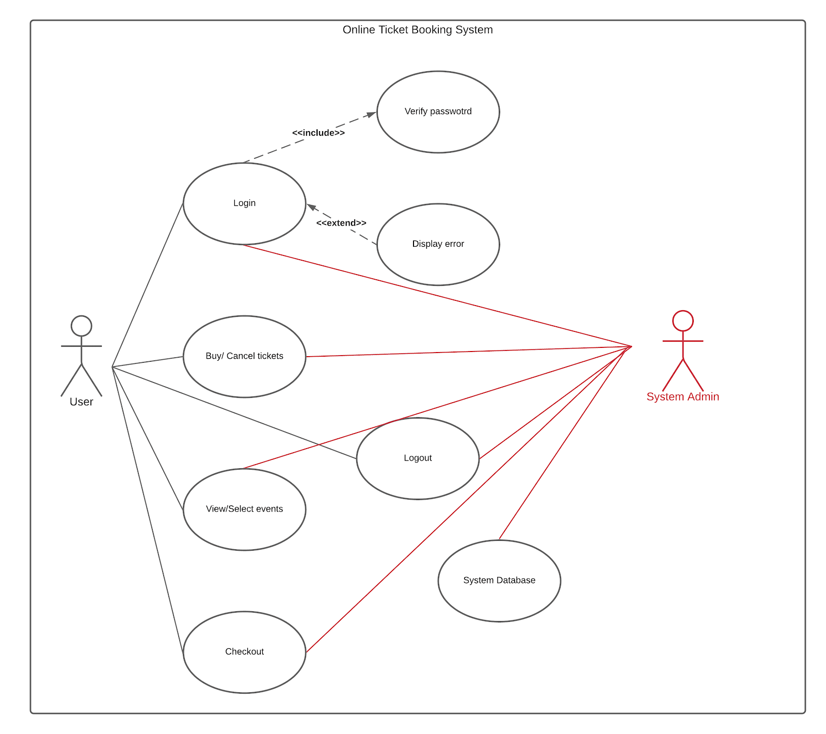

**UI Flow**

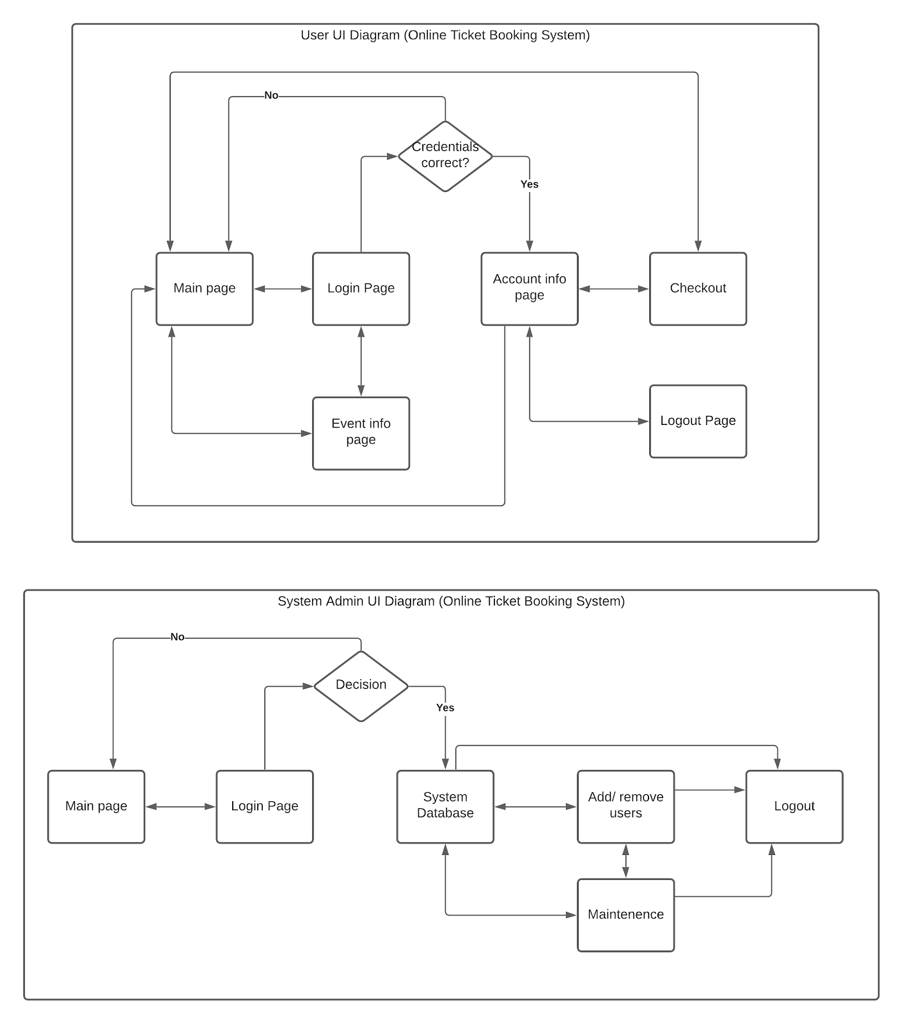

**UI Design (Part 1)**

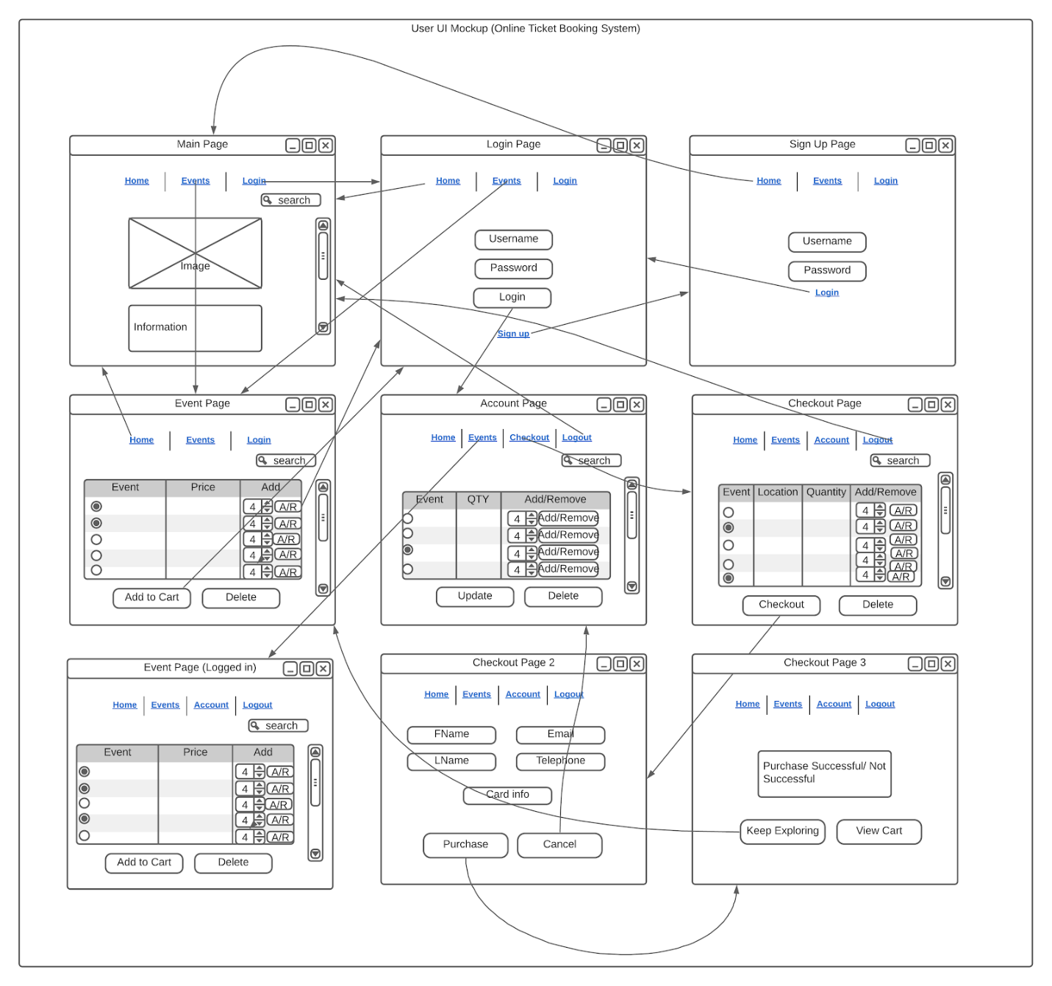

**UI Design (Part 2)**

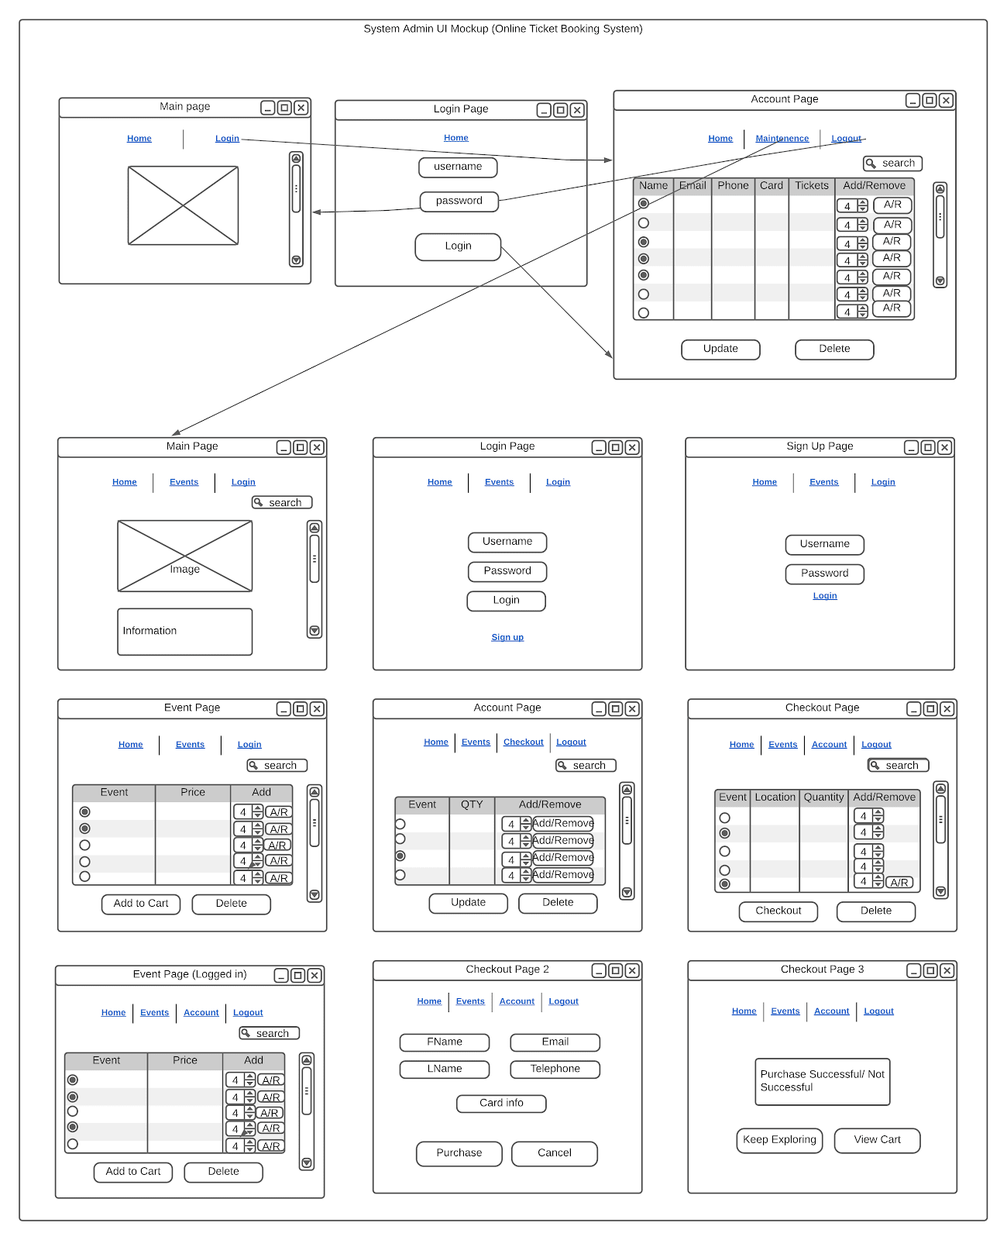

**Behavioral Design**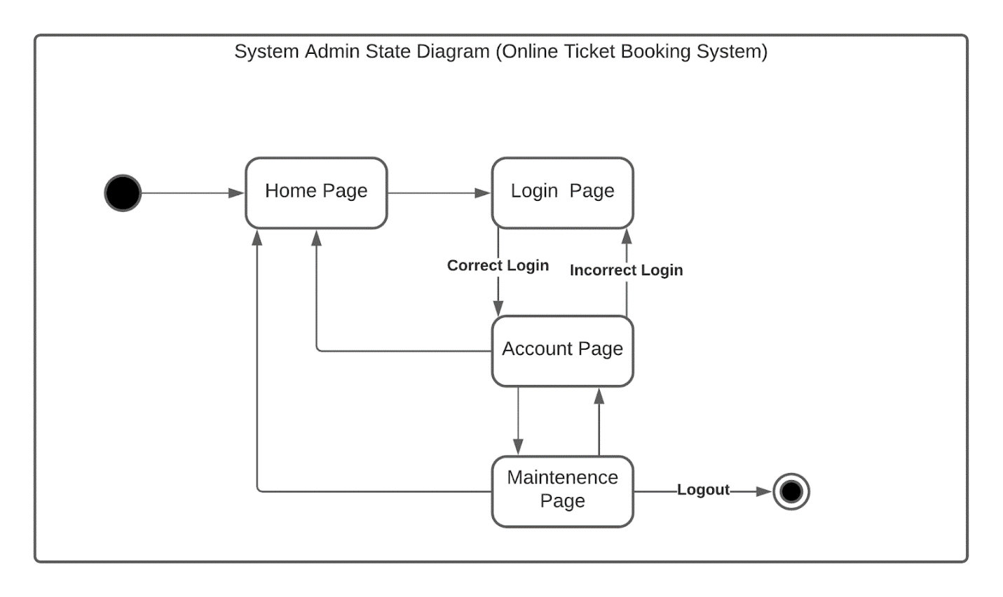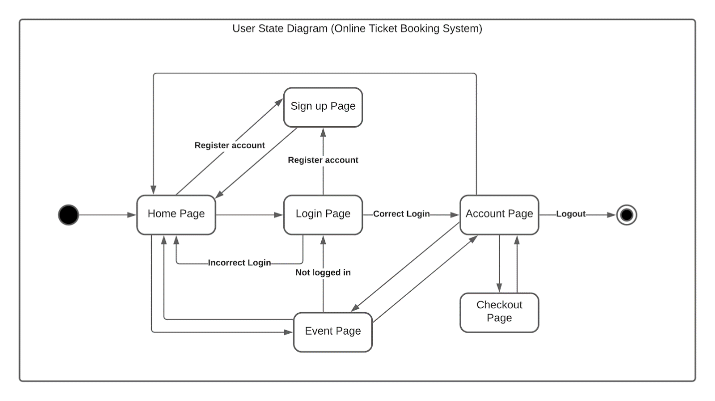

**Structural Design**

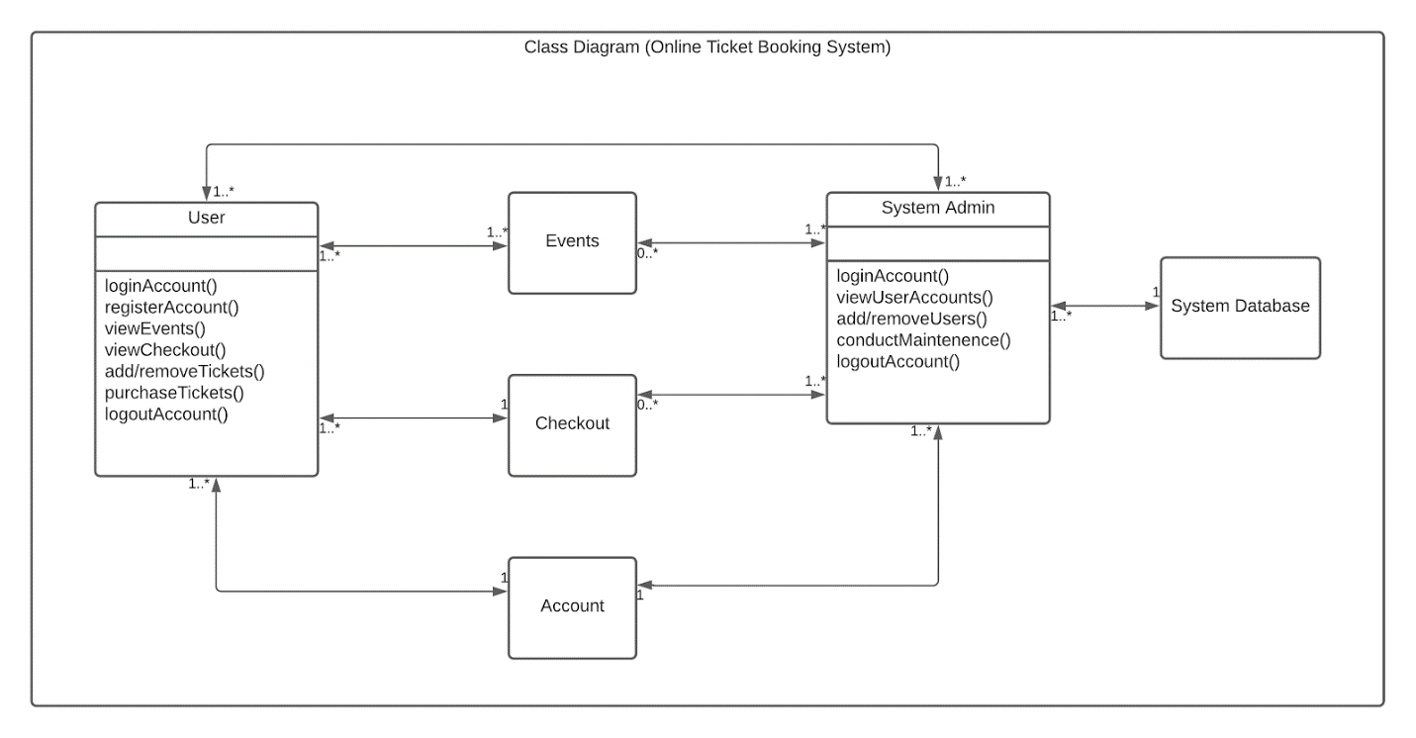

***Questions***

* Will the initial budget suffice throughout the project or are we going to need more funding in the future?
* Do we have all the necessary skills to implement a secure payment system and sophisticated database?
* Will our users find this new system better suited for them compared to the old one?
* Will the new system generate more profit for the agency and how long will it take for that to happen?

***Assumptions***

* We assume the website is smooth enough to support large traffic in the case of many users booking at the same time.
* We assume our website will provide secure methods to avoid user’s data being stolen.
* We assume that there’s a database in the backend to store a user’s data as backup.

***In scope***

The following features are within the scope of our website:

* Being able to access and to log-in to the website using user-info.
* Being able to access the event info page and browse a specific event to book.
* Being able to confirm and move to the checkout page to pay for the ticket.

***Not in scope***

The following feature is not currently in-cooperated in our website:

* Being able to book multiple events at the same time (If the events are different).

***Test cases***

|  |  |  |  |
| --- | --- | --- | --- |
| ***Test Case ID*** | ***Name*** | ***Description*** | ***Execution Result*** |
| 01 | User-credential | To check if the login values are valid | Allow the user or system admin to view the events if username and password matches the database data and deny access if it doesn’t. |
| 02 | Checkout confirmation | Check if the information is valid such as address and payment info. | Log user’s info to the database and keep it as a backup if it doesn’t already exist. |
| 03 | Event availability | Check if selected event is available at a certain date | Allow the user to select the event if the response is yes, prevent selection otherwise. |
| 04 | Credit card validity | Check if the card number/info is valid. | If it is, allow the user to make the purchase, otherwise deny access and print error on the screen. |

***Product Increment - Appendix G***

***Product Increment – all Product Backlog items completed during the Sprint and considered “Done” – meets the Definition of Done.***

|  |  |  |  |  |  |  |
| --- | --- | --- | --- | --- | --- | --- |
|  |  |  |  |  |  |  |
| ***Release: 11/30/20*** |  |  |  |  |  |  |
| ***Sprint 2 Done Date:***  ***10/21/20*** | ***Definition of Done***  ***Completions*** | | | | | |
|  | ***Design*** | ***Code*** | ***Testing*** | ***Documentation*** | ***Zero Defects*** | ***Item Usable*** |
| ***Increment:  Product ID’s*** |  |  |  |  |  |  |
| ***Create splash page (2-01)*** | ***x*** |  |  |  |  |  |
| ***Account registration & login (2-02)*** | ***x*** |  |  |  |  |  |
| ***View Events & User Data (2-03)*** | ***x*** |  |  |  |  |  |

***Burndown Chart***

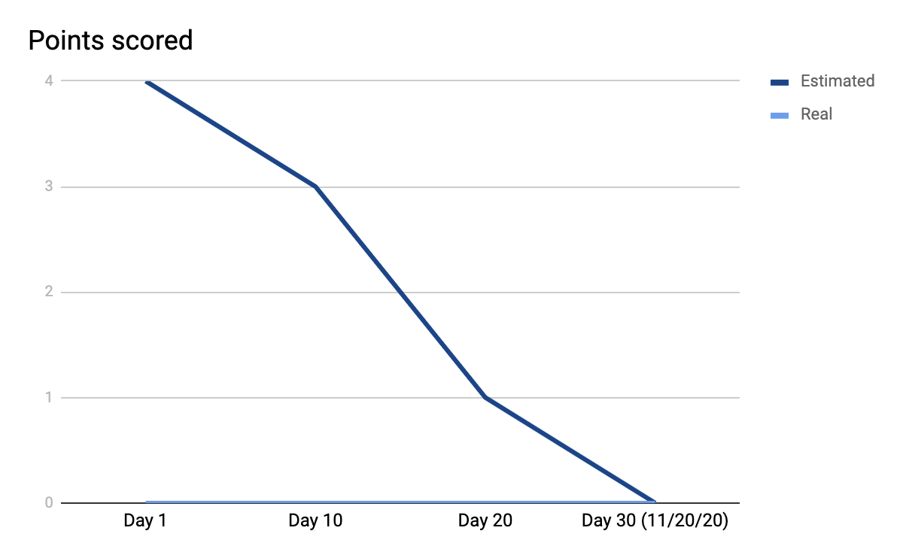

**Works Cited**

Schwalbe, K. (2019). Information Technology Project Management, 9th Edition. Cengage Leaning Course Technology. ISBN: 9781337101356

***Integrity Statement***

We affirm that the work submitted for the assignment is our own, was not outsourced, or provided by a third party, and all outside sources and references have been cited.



Daphne Gao:

10/21/2020



Mamadou Diallo:

10/21/2020



Jackson Gable:

10/21/2020

Cinthia De La Cruz:

10/21/2020



Rudy Bi:

10/21/2020

***Appendix A***

***Productivity Report***

|  |  |  |  |  |  |  |  |  |
| --- | --- | --- | --- | --- | --- | --- | --- | --- |
| Team Member | Tasks Completed |  | No. of Tasks Completed | Participation = (No. of Tasks Completed ÷ Total No. Tasks Completed) % | Date Tasks Completed | Review Changes | Reviewer Name | Date Review Completed |
| Daphne | Burndown Chart  Appendix G |  | 2 | 20% | 10/21/20 |  | Diallo | 10/21/20 |
| Mam-adou Diallo | Appendix F  (Objective/Goal/Strategic Fit, Requirements)  (Questions/Assumptions/Scope)  Test case, Reporting guidelines (all of it) |  | 3 | 25% | 10/21/20 |  | Rudy | 10/21/20 |
| Cinthia | Overview (1,2, 3), Project Backlog(1a,1b) |  | 2 | 20% | 10/21/20 | Citation was revised | Daphne | 10/21/20 |
| Rudy | Appendix F and G  Design(entire section) |  | 2 | 20% | 10/21/20 |  | Jackson | 10/21/20 |
| Jackson | Agile/Scrum- Sprint Backlog(2a,2b) |  | 1 | 15% | 10/21/20 |  | Cinthia | 10/21/20 |
|  | Totals |  | 10 | 100% |  |  |  |  |

***Lessons Learned Report***

|  |  |  |  |
| --- | --- | --- | --- |
| **#** | **Statement** |  |  |
| **1.** | **What the team did best?**   * Working as a team, helping one another, great collaboration. * Thoroughness, very good writing (good grammar, no copy and pasting) | | |
| **2.** | **What the team need to improve for the next deliverable?**   * Planning and dividing the task a bit more sooner | | |

1. Schwalbe, K. (2019). Information Technology Project Management, 9th Edition. Cengage Leaning Course Technology. ISBN: 9781337101356